Medical blog
Delta and theta waves during kundalini meditation.
We demonstrate using the muse headset and the muse eeg recording software
That there is a transition from alpha to beta to delta to theta waves as one meditates
In kundalini meditation progressively to the sahasrara chakra.
Contrary to much published research that reports an increase in beta waves by 60 to 120 percent [ref], we observe a greater than 120% increase in delta waves and a 20 to 50 percent increase in theta waves in deep meditation.
This is indicated by the following plots from the eeg software, on meditation by me.
A clinical study on a significant population of kundalini medtators at the rishikesh. Meditation center will supplement this publication.

Plot in rest state.

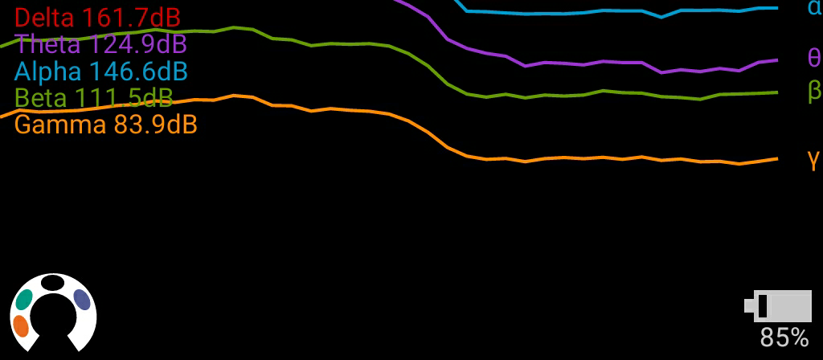

Plot in initiation state

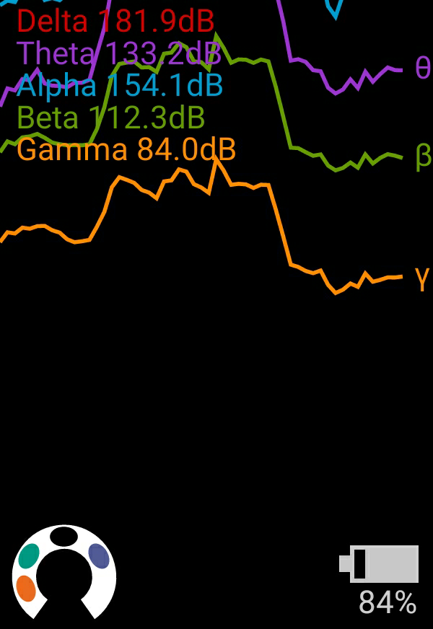

Plot indicating an increase in delta and theta waves in deep meditation.

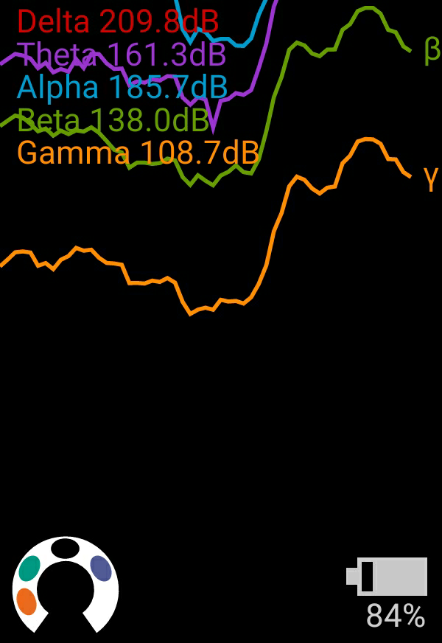

Conclusions and future work.
A theoretical analysis of the eeg results is to be carried out using a variety
Of mathematical transformations, including a Fourier transformation and analysis by normalisation, a generalised transformation study, chaotic analysis, [add more methods here].
We also need to formulate the criteria for bird chirp and consciousness level indication for Kundalini meditation.

